**KAMPALA PARENTS’ SCHOOL 2004**

**END OF TERM TWO 2023**

**SCIENCE**

**PRIMARY TWO**

DURATION: 2HRS 15 MIN

NAME: ............................................................................................

STREAM: ...............................................................……..……………

**SECTION A** (40 MARKS)

1. Identify any one bird which gives us eggs.

______________________________________________________________

1. How do we call things surrounding an organism?

____________________________________(**earth, environment**)

1. State one body exercise you know.

____________________________________________________________

1. Give any one body part.

______________________________________________________________

1. Why do we boil water for drinking?

______________________________________________________________

1. We wash our hands after visiting the toilet, to remove

______________________________________________________________

1. What is a home?

______________________________________________________________

1. Mention the main source of water.
2. ______________________________________________________________
3. ____________________diet is a meal that contains all food values in their correct amount. (**food, balanced**)
4. Underline the immunisable disease
   * 1. Flu, polio, cough
5. Name one example of food crop.

______________________________________________________________

1. What garden tool is used to collect rubbish?

______________________________________________________________

1. How useful are trees to people?

______________________________________________________________

1. Name the road sign drawn below.

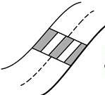________________________________________________

1. Write one example of a living thing found in a home.

______________________________________________________________

1. Give one reason why animals move from one place to another.

______________________________________________________________

1. Mention one product got from milk.

______________________________________________________________

1. How is the tool below useful to a farmer?

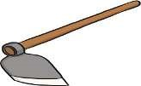_________________________________________________

1. Write any one animal without legs.

______________________________________________________________

1. Give one importance of insects to people.

_______________________________________________________________

1. Name one danger of poor feeding in children.

­­­_______________________________________________________________

1. Write the use of wings to an insect.

_______________________________________________________________

1. Write one health activity we do before eating food.

________________________________________________________________

1. Give any one way of making water safe for drinking.

________________________________________________________________

1. Name the second stage in the life cycle of a cockroach.

________________________________________________________________

1. Write one material people use to give first aid.

________________________________________________________________

1. Why are goats grouped under living things?

________________________________________________________________

1. Give any one use of water to people.

____________________________________________________________

1. Identify any one way of preventing fractures at school.

____________________________________________________________

1. Draw and name any one fruit.

|  |
| --- |
|  |
|  |

1. How is the sun useful to people?

____________________________________________________________

1. Why do we keep goats at home?

____________________________________________________________

1. What is soil erosion? ________________________________________

____________________________________________________________

1. 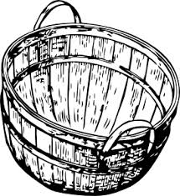Write any one material used to make the item below.

__________________________________________

1. Why does a rat move from one place to another?

_________________________________________________________

1. How can a P.2 pupil manage rainy weather?

__________________________________________________________

1. Give any one immunisable disease.

__________________________________________________________

1. What does a cow use to protect itself?

__________________________________________________________

1. Draw and name one material used to keep the body clean.

|  |
| --- |
|  |
|  |

**SECTION B (60MARKS)**

41. a) _______________________birds are birds which live in the bush.

(b)Give two examples of wild birds.

(i)____________________________ (ii)__________________________

(c) Mention any one use of birds to people.

________________________________________________________

42. What is personal hygiene?

__________________________________________________________________________________________________________________

(b)Name these things used to keep the body clean.

|  |  |  |
| --- | --- | --- |
|  |  |  |
|  |  |  |

1. How do we call animals which live in water?

__________________________________________________________

(**Dolphin animals, aquatic animals**)

(b)Give two examples of aquatic animals.

(i)____________________________ (ii)__________________________

(c)What food value is obtained after eating fish?

_________________________________________________________

1. ________________________is a sudden happening which cause injury or death to our body.

(b)Identify two examples of common accidents at home.

(i)________________________________________________________

(ii)_______________________________________________________

(c)Why should we give first aid?

_________________________________________________________

45- Study the leg below and answer the questions that follow.

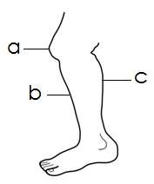

(a)Name the parts labeled;

a ________________ b ________________ c _____________

(b)How is a leg useful to people?

_________________________________________________________

1. **Match animals to their movement.**

Animal movement

Bird swimming

Snake flying

Fish slithering

1. What is the main natural source of heat and light?

_________________________________________________________

(b)Identify two uses of sun to people.

(i)________________________________________________________

(ii)_______________________________________________________

(c)Name this activity done during sunny day.

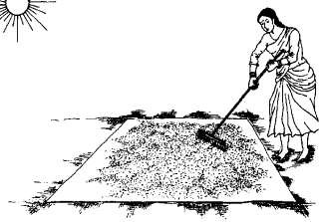_________________________________

1. How do we call a group of people related by blood, marriage or adoption?

_________________________________________________________

(b)Write two people found in a nuclear family.

(i)________________________________________________________

(ii)_______________________________________________________

(c)Give one role of a child at home. _________________________________________________________

49- Which clouds give us rain?

_________________________________________________________

(b)State three uses of water to people.

(i)________________________________________________________

(ii)_______________________________________________________ (iii)________________________________________________________

50- What is anything good to eat or drink?

_________________________________________________________

(b)Give any two examples of food we eat at school.

(i)________________________________________________________

(ii)_______________________________________________________

(c)Why do we eat food?

_________________________________________________________

**51- Match correctly.**

Pit latrine ironing them

Compound scrubbing

Toilet smoking

Clothes sweeping

1. Name the sense organs used for the following

Seeing_________________________________________________

Feeling________________________________________________

Hearing________________________________________________

Tasting _______________________________________________

1. **Study the insect below and answer the questions that follow**.

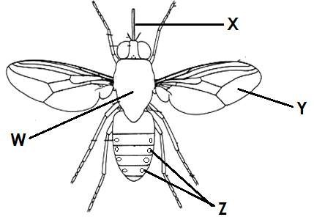

(a)Name the parts marked

W____________________________ X___________________________

Y____________________________

(b)How is part Z important to an insect?

_________________________________________________________

1. ________________________is the young plant in the garden. (**Germination, Seedling**)

(b)Name two conditions necessary for germination.

(i)___________________________ii) __________________________

(c)Identify any one seed grown in a nursery bed.

_________________________________________________________

55- Mention three immunisable diseases you know.

(i)__________________________ii) ___________________________

(ii)____________________________

(b)Which immunisable disease makes children lame?

_________________________________________________________